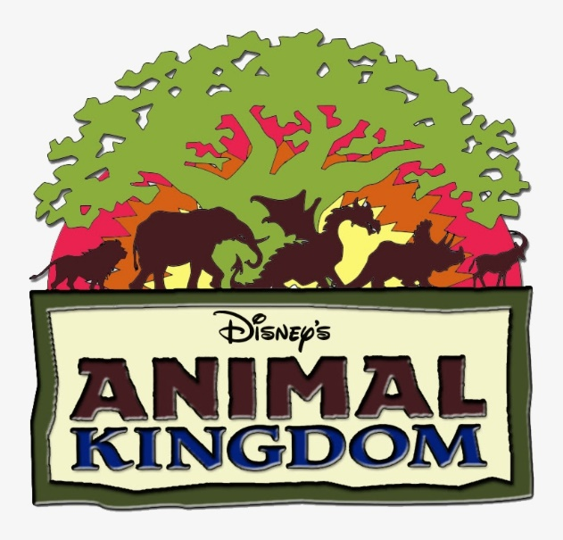
Today our trip takes us to Walt Disney World in Orlando Florida and the Animal Kindom. Here is a list of some rides and shows for us to experience. Go to www.youtube.com and search for each of these rides/shows under Walt Disney World r and the ride’s name. Example: Walt Disney World Primeval Whirl. When you are finished watching, write down which ride you like the best and why.

- Na’vi River Journey 6. Expedition Everest
- Avatar Flight of Passage 7. Finding Nemo-The Musical
- Festival of the Lion King 8. Primeval Whirl
- Kilimanjaro Safaris 9. It’s Tough to be a Bug
- Kali River Rapids 10. Gorilla Falls Exploration Trail

